**Estate Officer (Forwarded for scrutiny to Head clerk)**

**Step -1:**

**Open Service plus web portal:** (<https://tathyasathi.bangla.gov.in/>).

Login as **Estate Officer** in Service plus web portal.

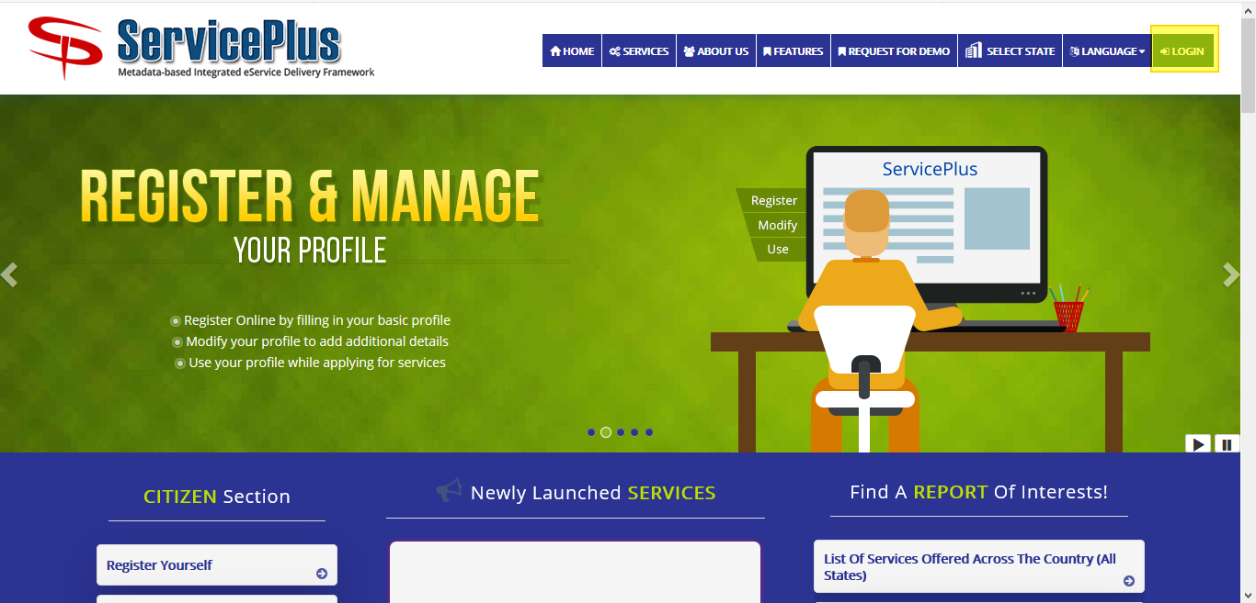

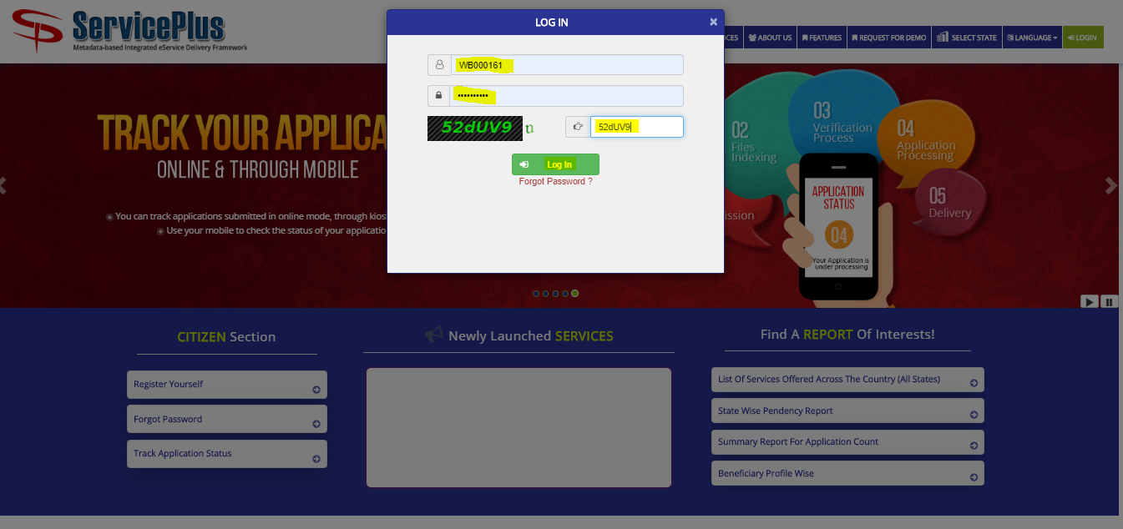

**Step 2:**

Now Go to **“Message Box”** and select **“Inbox”**.

In Inbox select the service **“Application for Change of Flats in Bidhannagar Municipal Corporation Area”** and select the task **“Application Receipt by Estate Officer cum Joint Secretary”** and select **“Get Data”.**

Select **“Pull”/ “Take Action”** to take action.

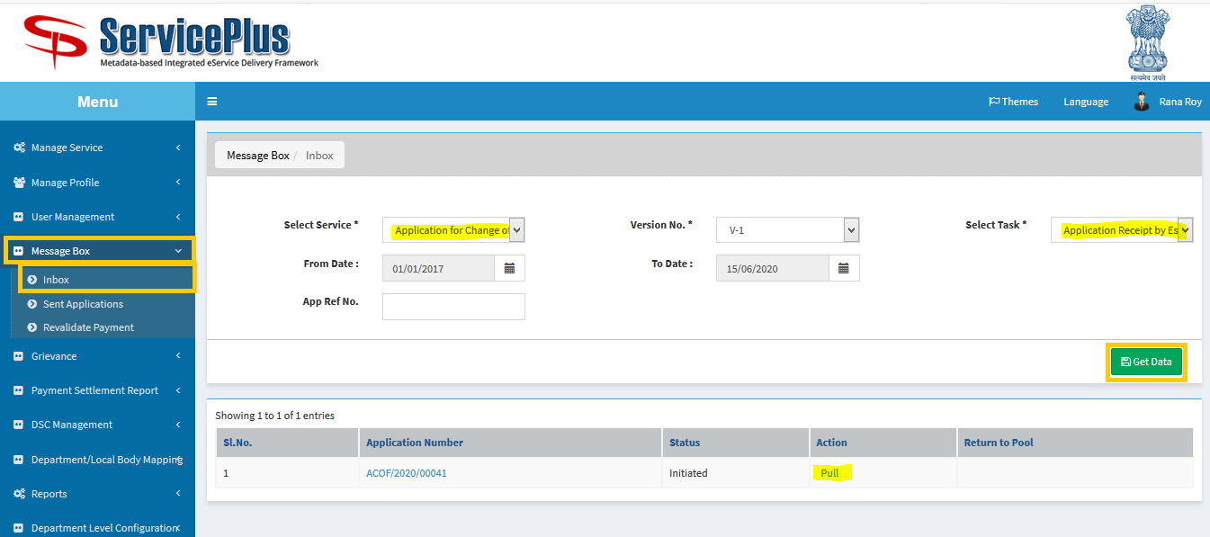

**Step 3:**

Select **“View Processing History”** to see the history of the application.

Action of the form can be taken by **Estate Officer** by taking action in two steps to **forward** and **Forward To-Supervisory Head Clerk** for Verification to “**Head Clerk”** and Give remarks and **submit**.

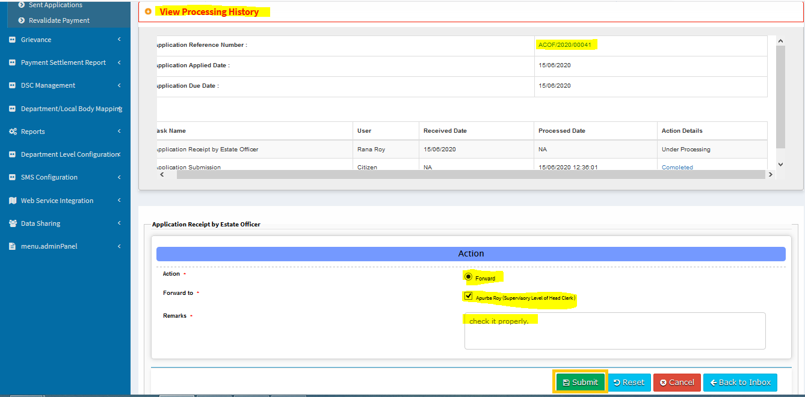

Now the application sent to head clerk successfully.

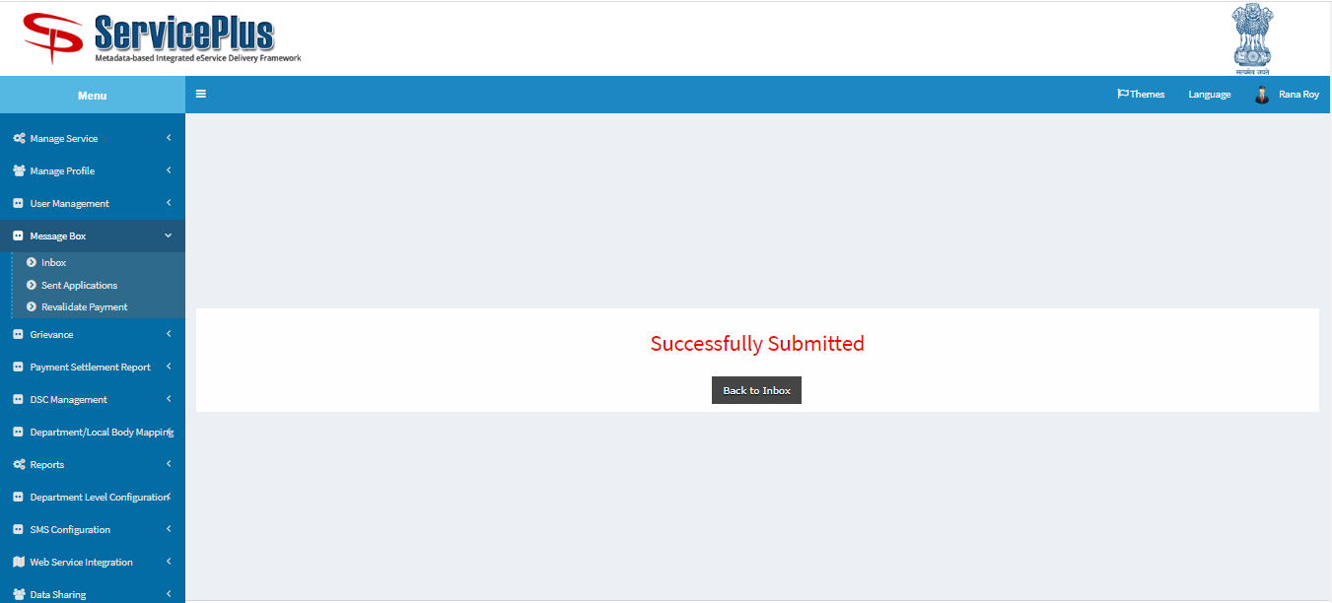

**HEAD CLERK (Scrutiny and Forwarded for shortfall or Preparation License)**

**Step 4:**

At first login to Service plus web portal**: (**<https://tathyasathi.bangla.gov.in/>).

Login as “**Head Clerk**” in Service plus web portal.

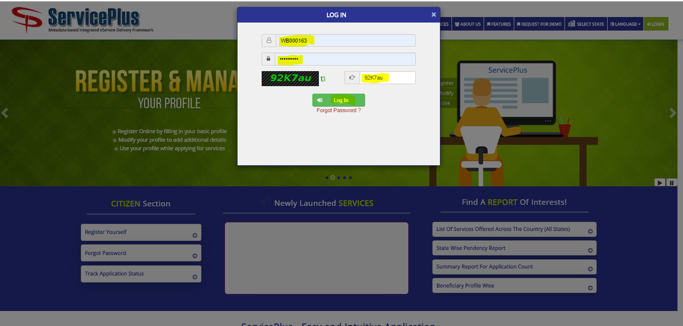

**Step 5:**

Now Go to **“Message Box”** and select **“Inbox”**.

In Inbox select the service **“Application for Change of Flats in Bidhannagar Municipal Corporation Area”** and select the task **“Verify and Token Generation”** and select **“Get Data”.**

Select **“Pull”/ “Take Action”** to take action.

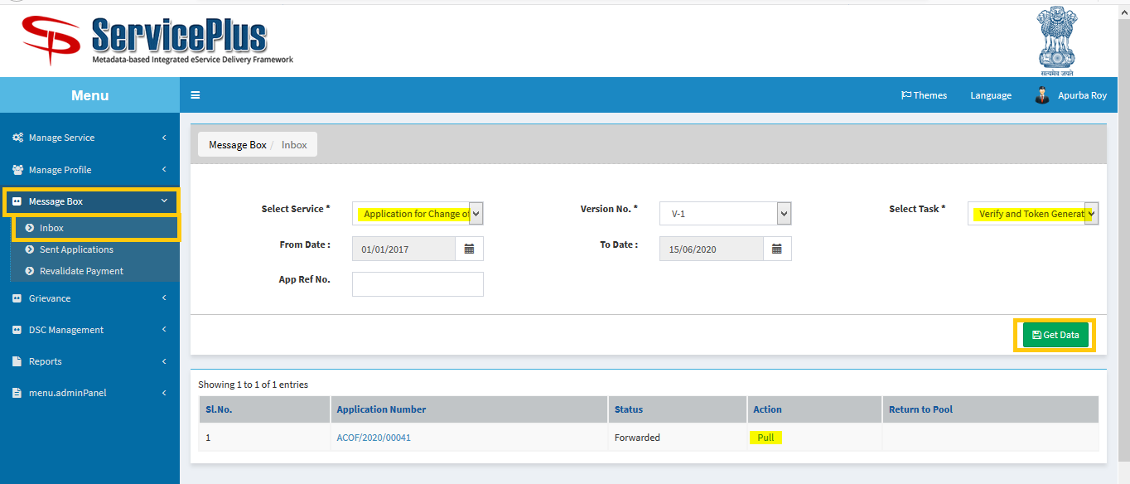

**Step 6:**

Select **“View Processing History”** to see the history of the application.

Now Click **“Check”** button to check if there is no duplicate application.

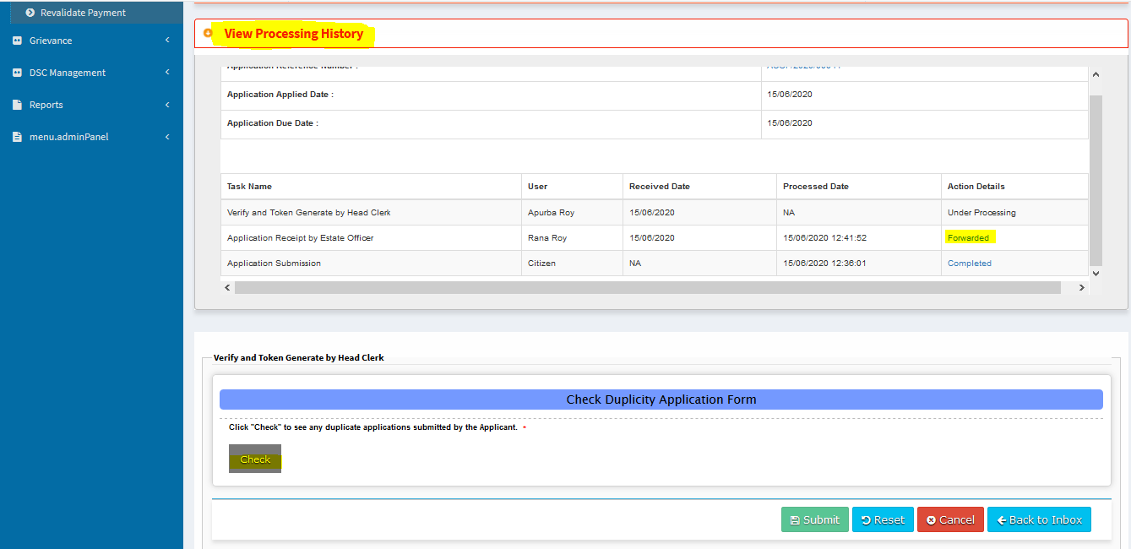

If no same application found there then this message will be shown.

Click “**ok”** to continue.

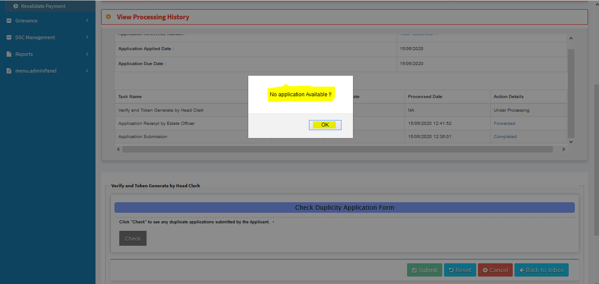

**Step 7:**

Now **Head Clerk** can process the application by forwarding to –

**Allotment and Prepare License by Head Clerk**

**Application Submission** **Short fall**

**Recommend for rejection**.

Click on **Forward** then **Allotment and Preparation License by Head Clerk**

Select **Flat Category** Then click on **“Token Generation”** button.

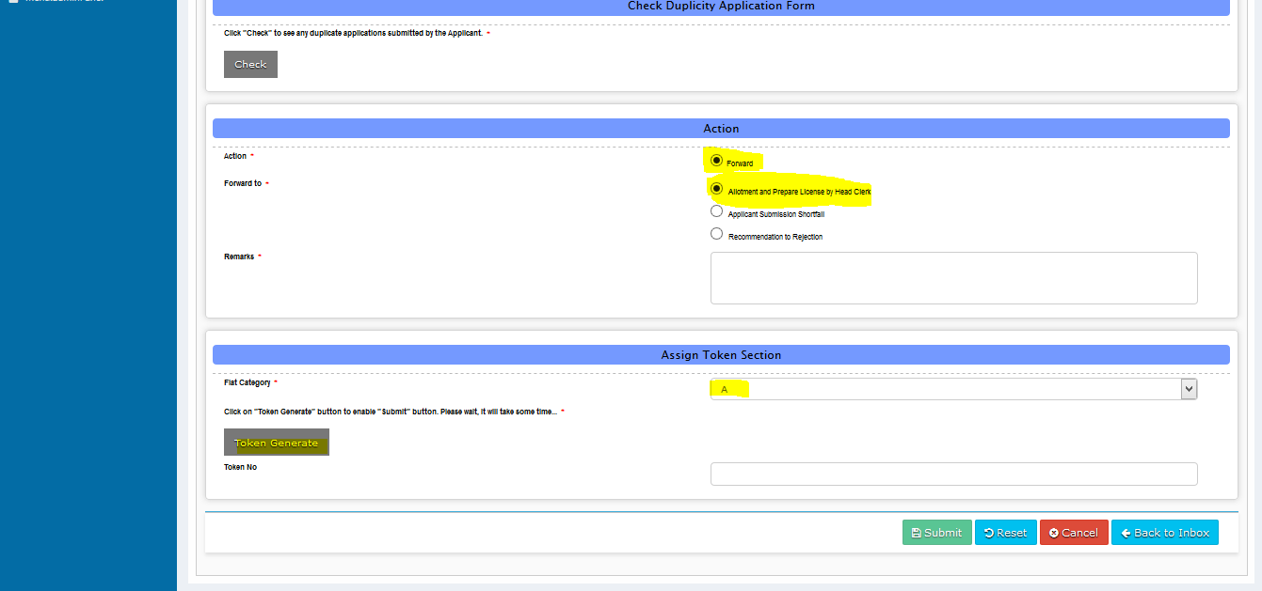

This Message will be shown after successful token generation.

Now click on **“ok”** to continue.

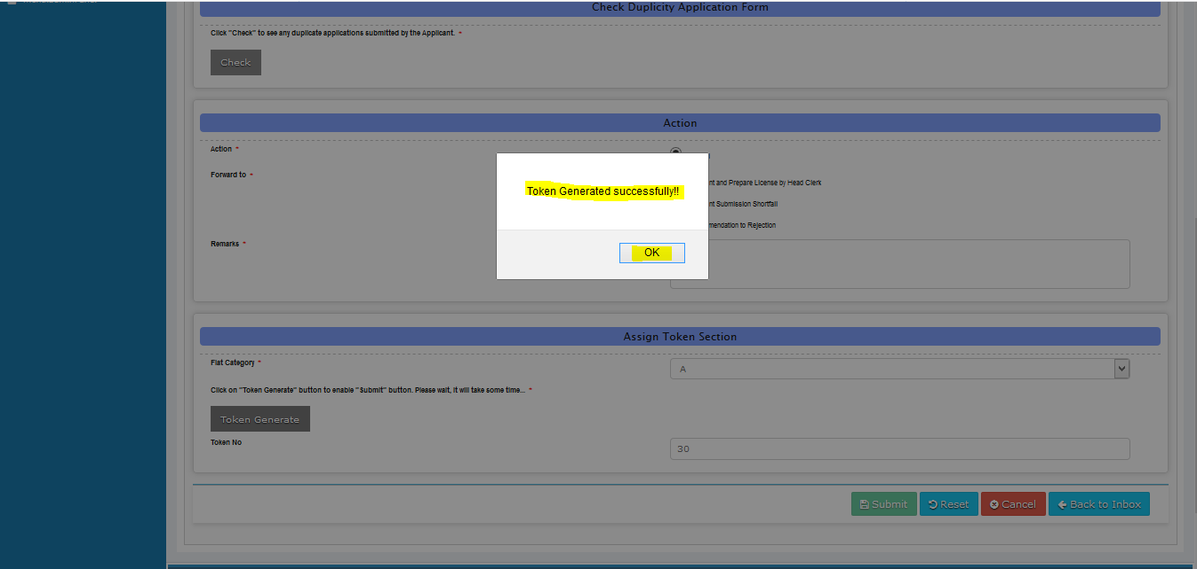

**Step 8:**

Give **Remarks** and **submit.**

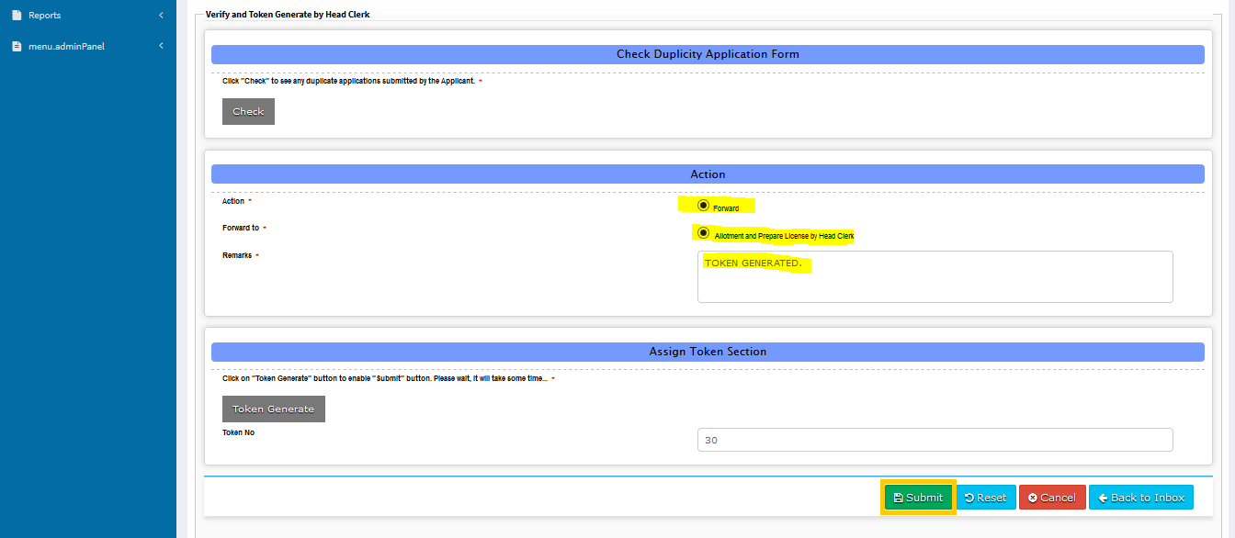

**HEAD CLERK**

**(Allotment and Prepare License by Head Clerk)**

**Step 9:**

Now go to **“Allotment and prepare License by Head Clerk Task”.**

Click on **“View processing History”.**

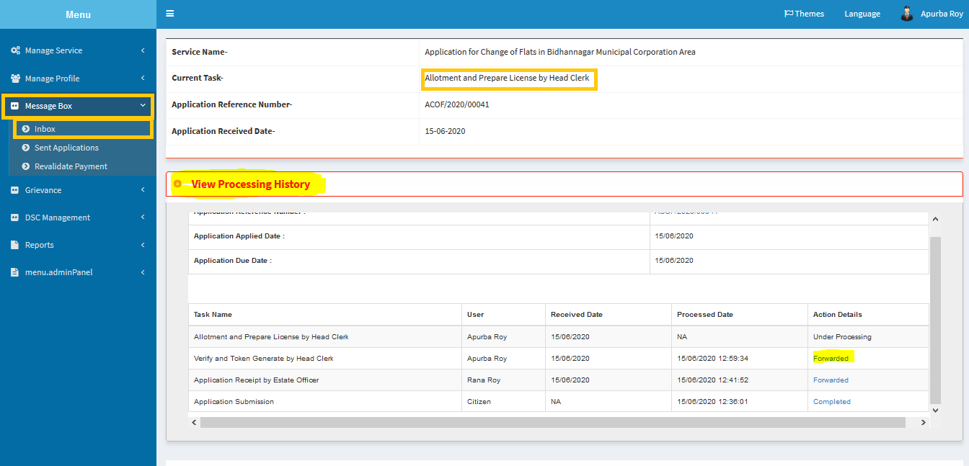

**Step 10:**

Click on **forward**,

Then select **Flat Category**.

Now click on **“Check Flat Availability”.**

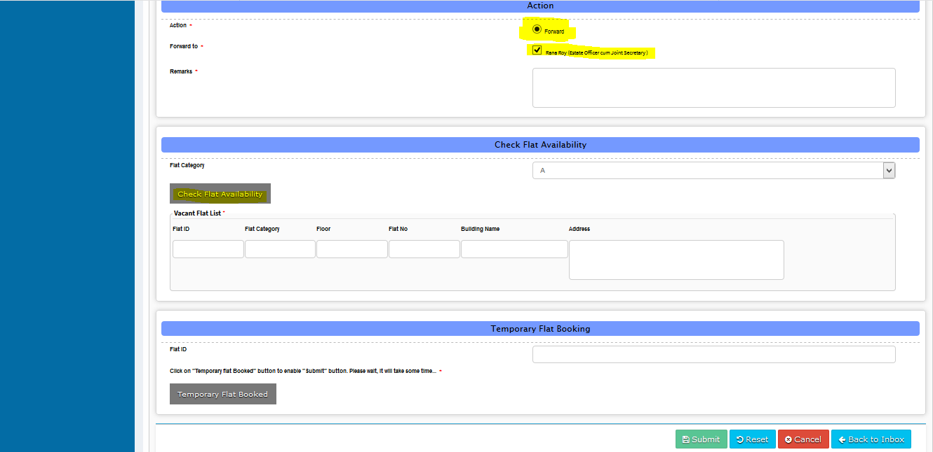

**Step 11:**

Now put available Flat id from the list.

Then Click on **“Temporary Flat booked”.**

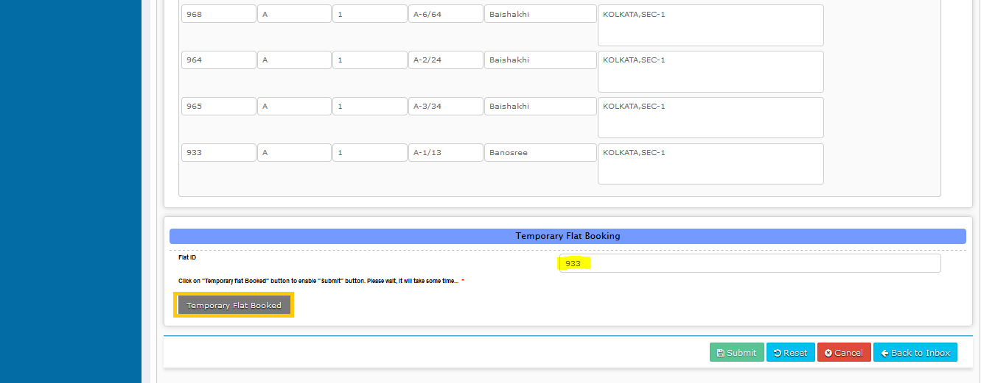

After successful Temporary booking this message will be shown.

Now click on **“ok”** to continue.

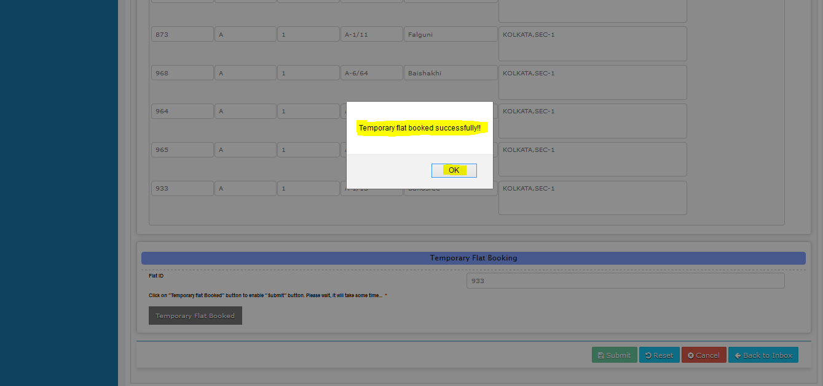

**Step 12:**

Fill the required Details for License.

Then click on Submit.

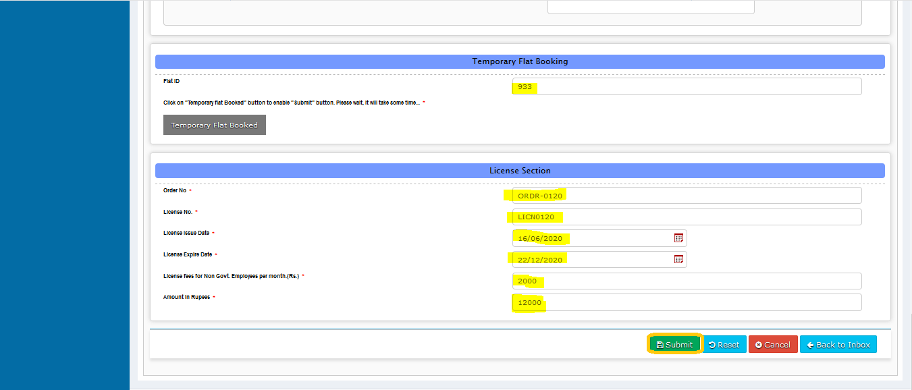

**Step 13:**

Here download file by clicking the **file** icon and **submit**.

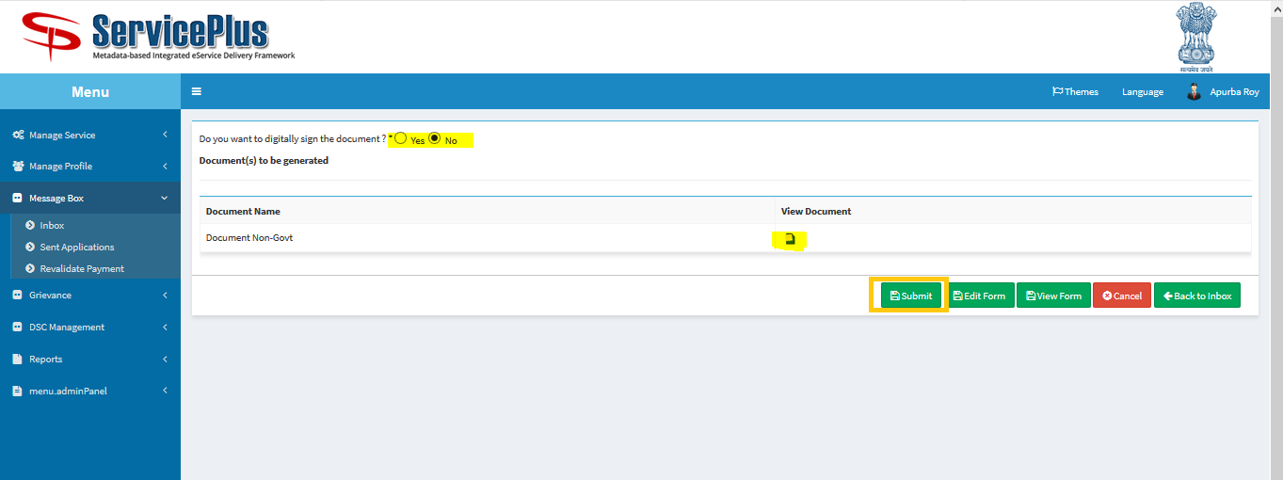

**This is the License Copy.**

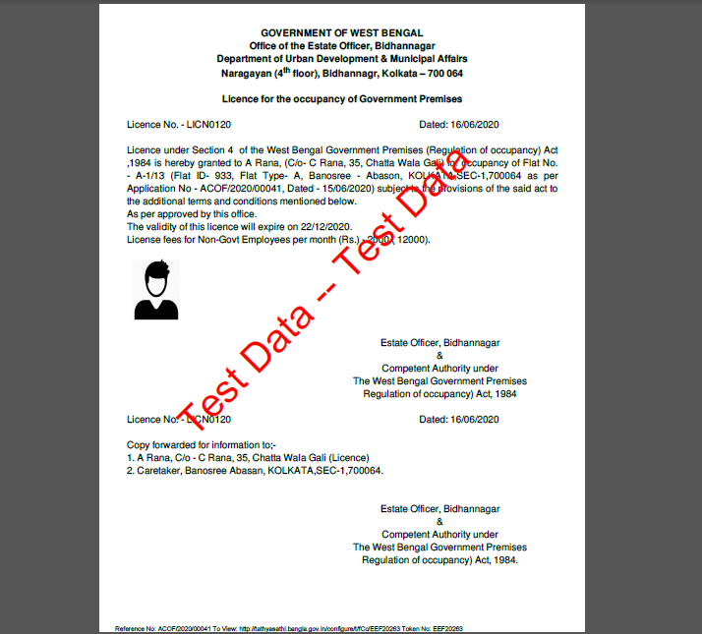

Now the application sends to Estate officer successfully.

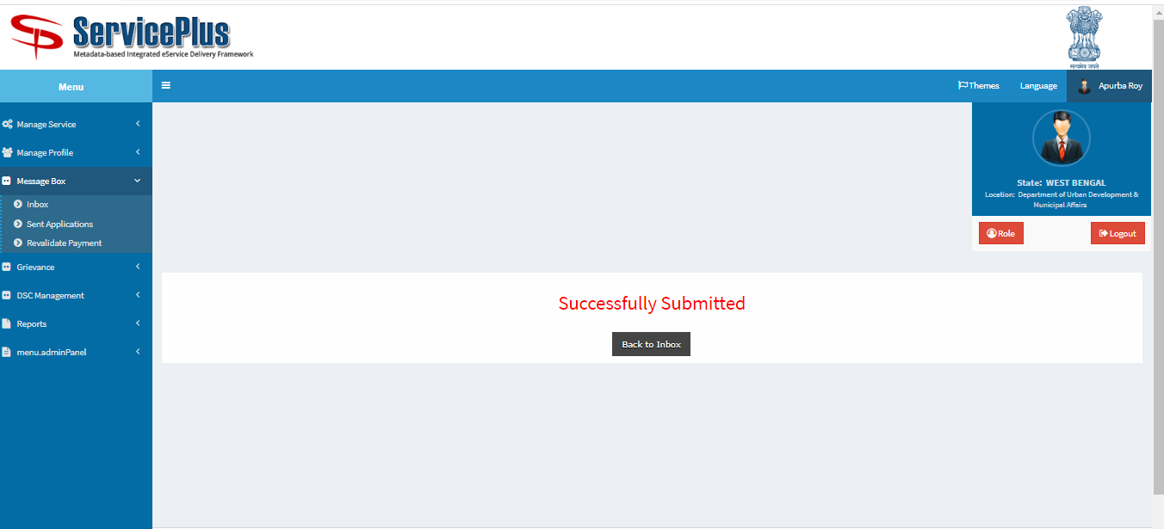

**Estate Officer (Generation of License)**

**Step 1:**

Again Login as **“Estate Officer**” in Service plus web portal.



**Step 2:**

Select the service **“Application for Change of Flats in Bidhannagar Municipal Corporation Area”** and select the task **“Issuance of License by Estate Officer”** and select **“Get Data”.**

Select **“Pull” / “Take Action”**.

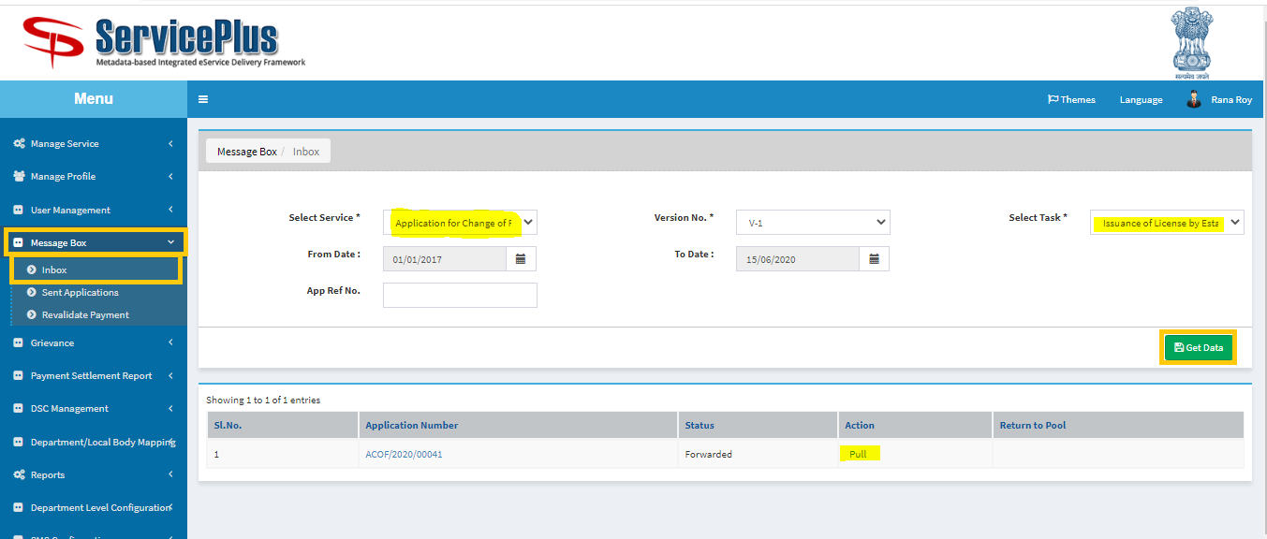

**Step 3:**

Select **“View Processing History”** to see the history of the application.

Action of the form can be taken by **Estate Officer** by taking action to **forward** or **reject.**

Now select **forward** then **Physical Possession by Applicant.**

Or reject the application by selecting **Reject**.

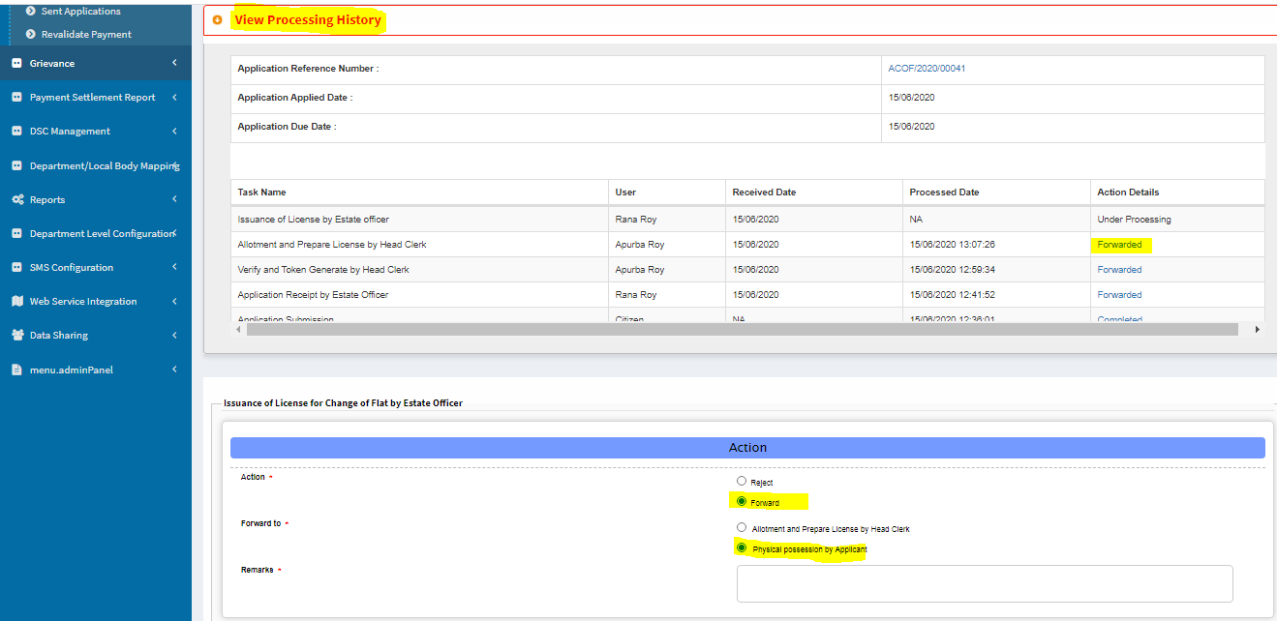

Or revert back by selecting **“Allotment and License generation by Head clerk”.**

Give “**reasons for revert back”**.

Then click on **“Free Temporary Booked Flat data”** to enable “**submit**” button**.**

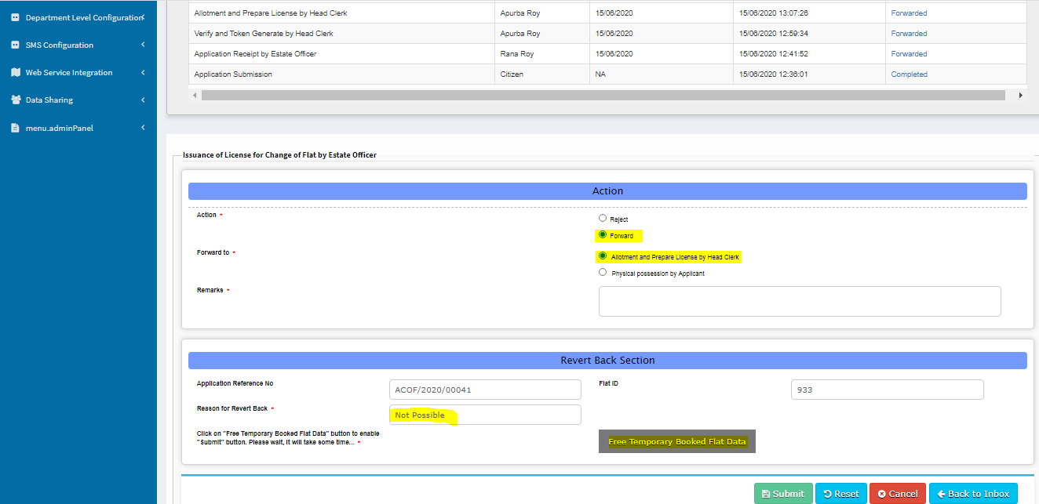

For the Case of **“Physical possession by applicant”** click on “**Update Flat booked data”.**

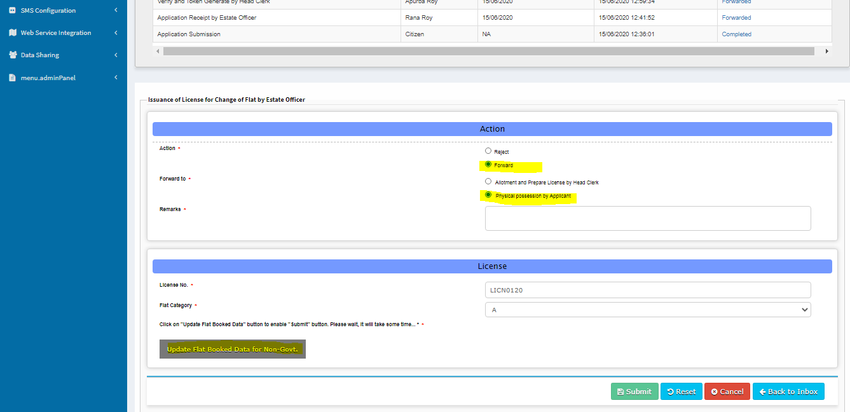

After successful **updation** this message pops up.

Click **“ok”** to continue and **submit**.

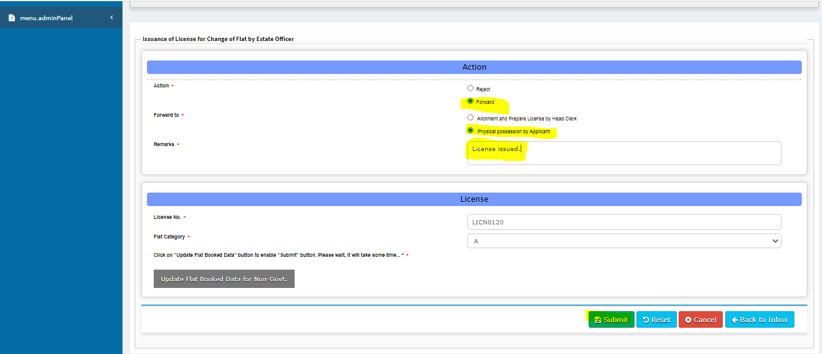

Upload The **License Copy** & **submit**.

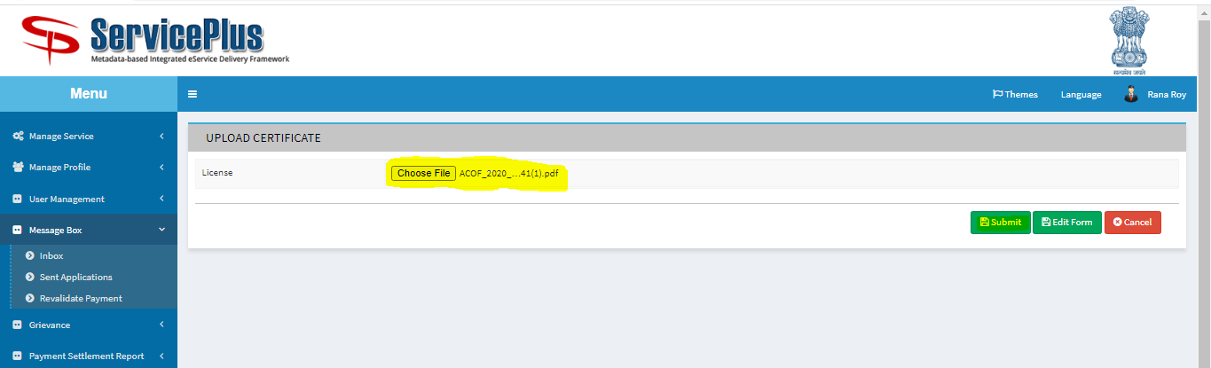

**This is the License Copy.**

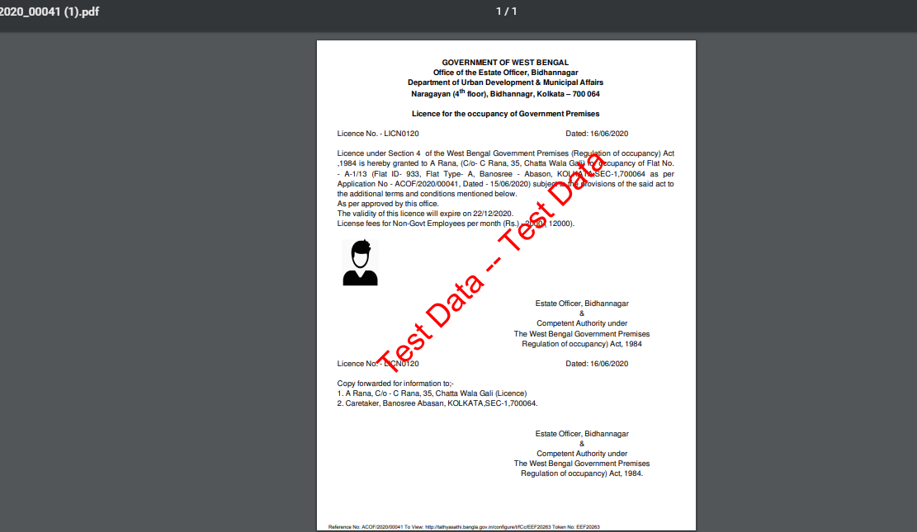

Now the License Copy sent to Applicant successfully.



**HEAD CLERK (Deliver the Application)**

**Step 1:**

Again Login as **“Head Clerk**” in Service plus web portal.



**Step 2:**

Select **“View Processing History”** to see the history of the application.

Action of the form can be taken by **Head Clerk** by taking action to **deliver.**

And then clicking on **“Update Flat Allocation details** button.

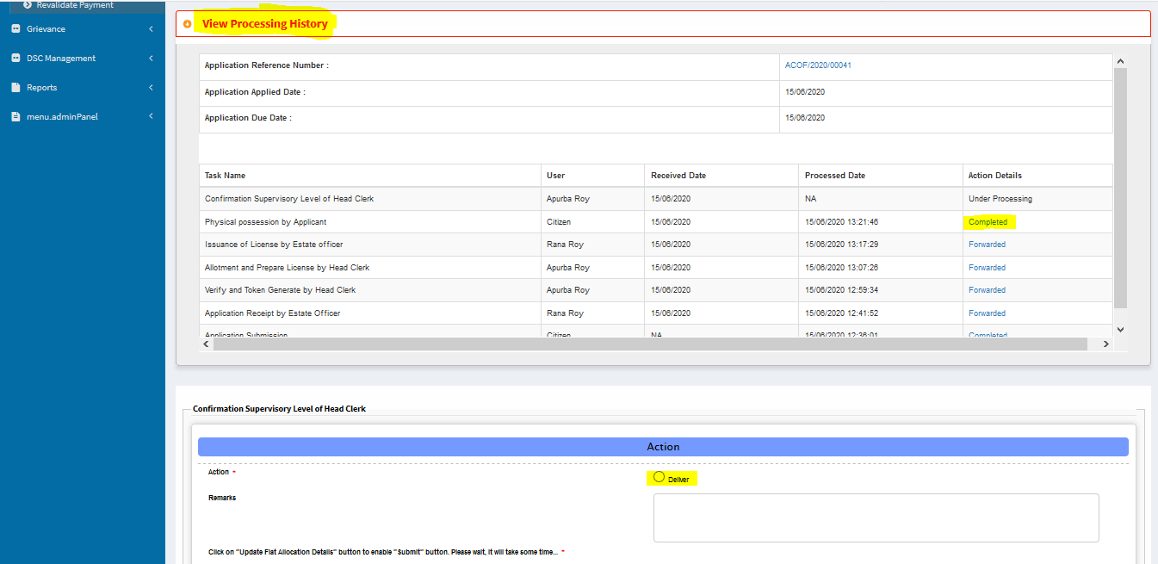

Give **remark** and click on the **“Update flat Allocation Details”.**

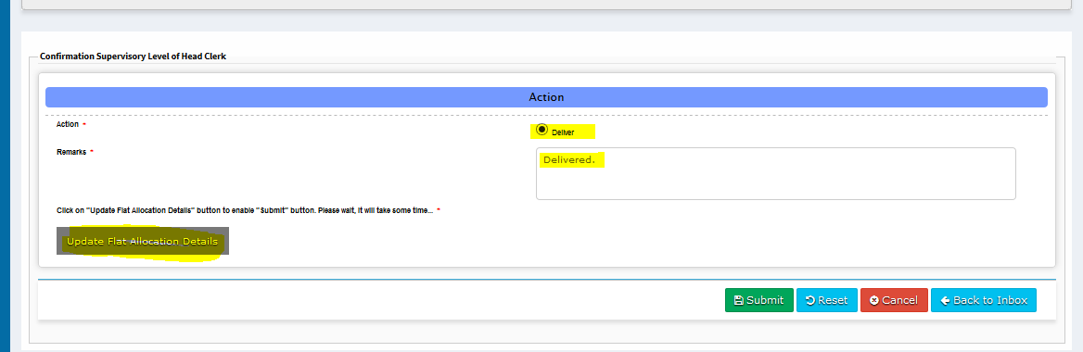

After successful **updation** this message pops up.

Click **“ok”** to continue and **submit**.

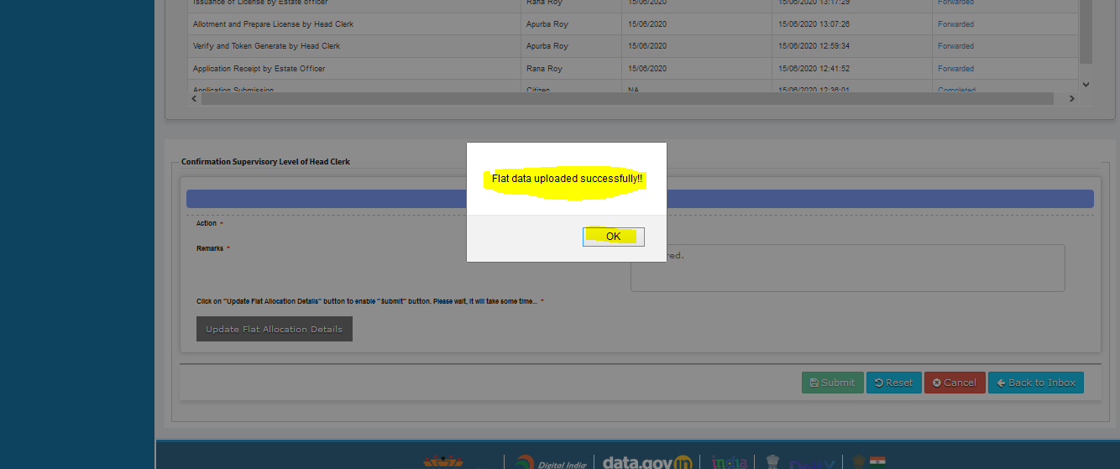

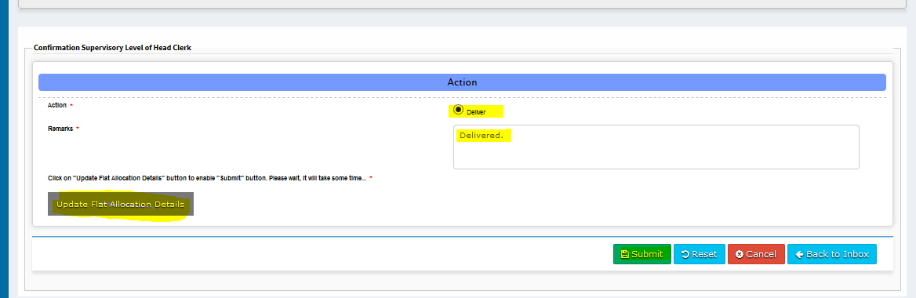

Now The License Copy Delivered Successfully.



**SHORTFALL CASE**

**HEAD CLERK (Shortfall)**

**Step 1:**

Again Login as **“Head Clerk**” in Service plus web portal.



**Step 2:**

Select the service **“Application for Change of Flats in Bidhannagar Municipal Corporation Area”** and select the task **“Verify and Token Generation by Head Clerk”** and select **“Get Data”.**

Select **“Pull” / “Take Action”**.



**Step 3:**

Select **“View Processing History”** to see the history of the application.

Action of the form can be taken by **Head Clerk** by taking action to **forward** and **Applicant Submission Shortfall** and the reason for rejection**.**

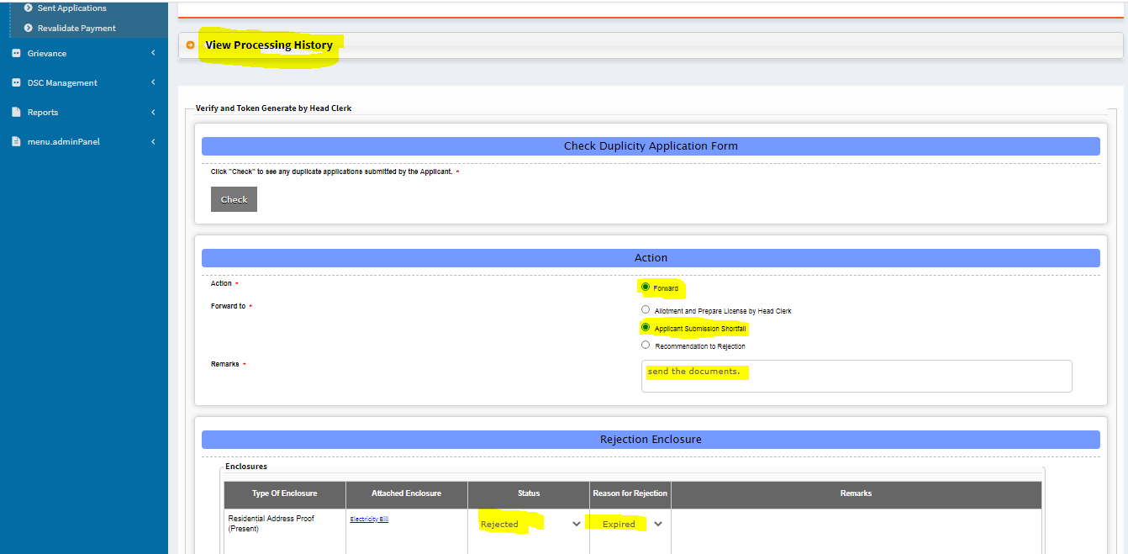

Mentioned the document for Shortfall & put remarks then click on submit.

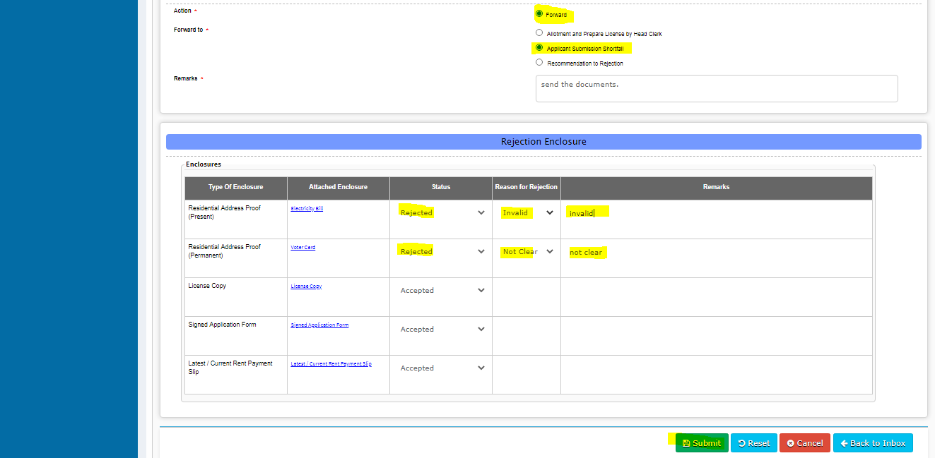

After successful **submit** this message pops up.

Click **“ok”** to continue and **submit**.

